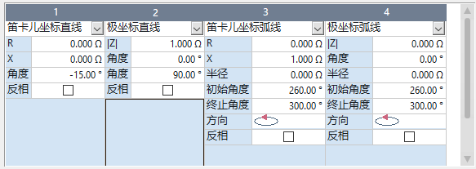

BEGIN ZONE

INDEX 3

TYPE TRIPPING

FAULTLOOP LL

LABEL "Z3"

TRIPTIME 0.8

ACTIVE YES

BEGIN LENSTOMATOSHAPE

ANGLE 75

OFFSET 5

REACH 10

INVERT NO

WIDTH 10

END LENSTOMATOSHAPE

END ZONE

BEGIN ZONE

INDEX 1

TYPE EXTENDED

FAULTLOOP LL

LABEL "Z1B"

TRIPTIME 0

ACTIVE YES

BEGIN SHAPE

LINE 0, 0, 120.002, LEFT

LINE -5.00636, 0, 78.9492, LEFT

LINE 0, 7.16, 0, LEFT

LINE 5.00011, 0, -101.001, LEFT

LINE 0, 0, 158.001, LEFT

AUTOCLOSE YES

INVERT NO

END SHAPE

END ZONE

BEGIN ZONE

INDEX 1

TYPE STARTING

FAULTLOOP LL

LABEL "ZS1 L-L"

TRIPTIME 1.5

ACTIVE YES

BEGIN SHAPE

LINE 0, 0, -30, LEFT

ARCP 0, 0, 10, -30, 135, CCW, LEFT

LINE 0, 0, -45, LEFT

AUTOCLOSE YES

INVERT NO

END SHAPE

END ZONE

BEGIN ZONE

INDEX 2

TYPE STARTING

FAULTLOOP LL

LABEL "ZS2 L-L"

TRIPTIME 2

ACTIVE YES

BEGIN SHAPE

ARCP 0, 0, 10, 0, 360, CCW, LEFT

AUTOCLOSE YES

INVERT NO

END SHAPE

END ZONE

BEGIN ZONE

INDEX 1

TYPE TRIPPING

FAULTLOOP LL

LABEL "Z1"

TRIPTIME 0

ACTIVE YES

BEGIN MHOSHAPE

ANGLE 75

OFFSET 0

REACH 6

INVERT NO

END MHOSHAPE

END ZONE

BEGIN ZONE

INDEX 3

TYPE TRIPPING

FAULTLOOP LL

LABEL "Z3"

TRIPTIME 0.8

ACTIVE YES

BEGIN LENSTOMATOSHAPE

ANGLE 75

OFFSET 5

REACH 10

INVERT NO

WIDTH 10

END LENSTOMATOSHAPE

END ZONE

BEGIN ZONE

NAME Z1

TIME1 0.

TIMEM 0.

BEGIN TRIPCHAR

START 0.825 -0.4763

LINE 1.541, 3.311

LINE -0.2893, 3.311

LINE -0.825, 0.4763

LINE 0.825, -0.4763

CLOSE

END TRIPCHAR

BEGIN TRIPCHAR-EARTH

START 6.263 -0.9826

LINE 7.074, 3.311

LINE -5.736, 3.311

LINE -5.736, 3.311

LINE 1.702, -0.9826

CLOSE

END TRIPCHAR-EARTH

END ZONE

BEGIN DIFFBIAS

ACTIVE YES

BEGIN DIFF

IDIFF>> 5

TDIFF>> 0.023

IDIFF> 0.3

TDIFF> 0.03

END DIFF

BEGIN BIAS

DEFBIAS 2

BIASDIVISOR 2

END BIAS

BEGIN TRIPCHAR

START 0, 0.3

LINE 0.5, 0.3

LINE 2, 0.8

STOP 5, 3.6

END TRIPCHAR

END DIFFBIAS